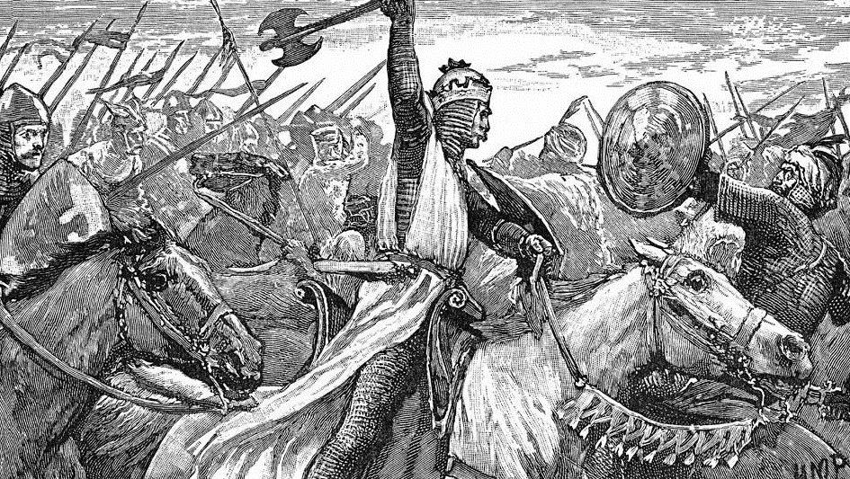
Novembertristesse 25
c

The Dark Ages

What: DBMM 2.1 Rules & current Commentaries (www.dbmm.org.uk) – 400 AP
Armies from 476 AD to 1072 AD ! (The Dark Ages)
When: Friday, 31/10/2025 from 5 pm to Sunday, 02/11/2025 at about 5 pm
Where: Willi-Salzmann Halle – Heldenbergerstr.16, 61130 Nidderau
Nidderau is about 43 km away from Frankfurt Airport and it is accessible by train.
Transfers can be arranged.
Lists to be submitted until 30/09/25 the latest to additz add web dot de
Delayed lists will cause a deduction of: 5 VP
If no list is submitted this will cause a deduction of 20 VP
Playing time: Each game ends immediately after 3,5 hours.
All unsettled combats are to be executed, if the game is in that phase at that time.

Schedule: Saturday 1.game 9:00 am – 12:30 pm
Lunch break / Opportunity to visit the Ronneburg *
2.game 4:00 pm – 7:30 pm
Joint Dinner 8:00 pm **
Sunday 3.game 8:30 am – 12:00 am
Lunch break 12:00 am – 1:00 pm ***
4.game 1:00 pm – 4:30 pm
Award ceremony 4:45 pm
The Runners & Riders will be announced in advance – but disconnected.
There will be a price for that gamer
who can assign the most gamers to their armies correctly.
* The Ronneburg is about 18km away from Nidderau. It was built before 1258, i.e. during the lifetime of Gerlach II von Büdingen, who was the imperial bailiff in the Wetterau. That is why it belongs to the series of fortified castles of the "Imperial Wetterau" ordered by the Staufian kings at the beginning of the 13th century. If you want to visit the castle please state “Ronneburg” at your registration (see below). https://burg-ronneburg.de/
Light meals / Take away
** Hessenschmaus https://www.hessenschmaus.de/
*** Sushi & Asiatisch: Tea Su https://teasu.simplywebshop.de/listArticle
Kebap & Pizza: Urfa Kebap-Haus
Bakery: Philipp’s Backstube open on Sat. til 12:30 am / on Sun. til 11:00 am
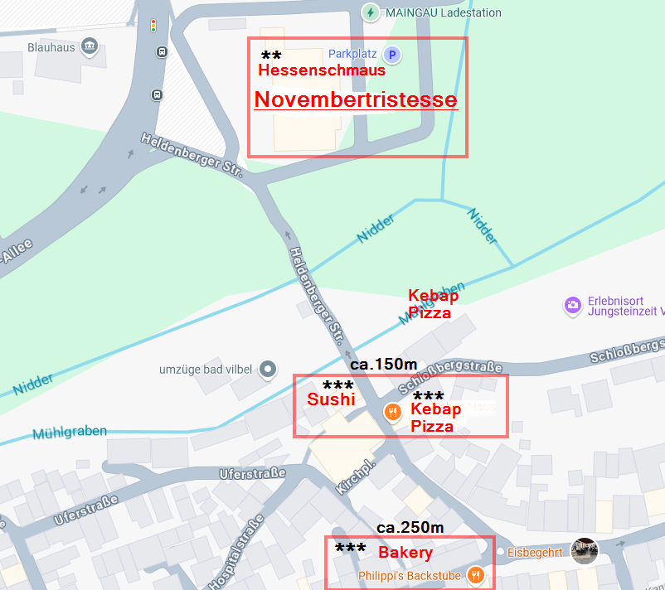
Accommodation: https://www.nidderau.de/erleben-entdecken/freizeit-tourismus/unterkuenfte/
Tournament fee: 45,-€ - Beverages (Beer, Water, Softdrinks & Coffee) and Snacks are included.
Registration: automatically with incoming payment
Money transfer: Please transfer the fee with the keyword „Novembertristesse 25“ or “Ronneburg”
until September, 30th to
DE08 6009 0800 0005 1112 99 / GENODEF1S02 / Axel Heinz /
Sparda-Bank Baden-Württemberg eG

